April 1, 2024
Dear Resident,
Your Building Name and San Francisco Environment Department want to remind you that compostable and recyclable materials are prohibited in the trash (landfill) bins and trash chutes. The Mandatory Recycling and Composting Ordinance requires that “All persons in San Francisco must separate their refuse into recyclables, compostables and trash” and “No person may mix recyclables, compostables or trash, or deposit refuse of one type in a collection container designated for another type of refuse.”
On the property there are bins or chutes to:
- Compost - food scraps, soiled paper, plant trimmings and compostable bags labeled BPI certified compostable
- Recycle - flattened cardboard, clean paper, bottles, cans, clean aluminum foil and hard plastics (cups, tubs, etc.); and
- Landfill – Styrofoam, broken ceramics and broken glass, disposable gloves, face masks, snack wrappers, diapers
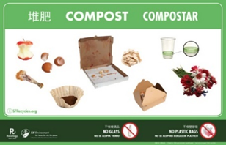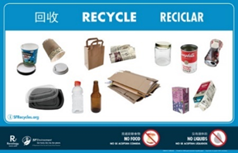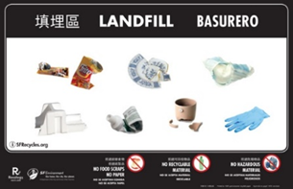
Please contact property management if you do not know where all recycling or compost bins are located or if you did not receive a recycling guide with more detail about where to put your materials.
You can also find out where to put items by visiting sfrecycles.org
Thank you,

Your Building Name and San Francisco Environment Department

